**R PROGRAMMING**

**MATRIX:**

**………………**

a<-matrix(c(12,56,78,90,34,56,78,90,23,47,84,16), nrow=3,ncol=4)

a

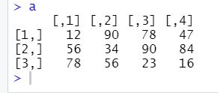

**PIE PLOT**

**……………….**

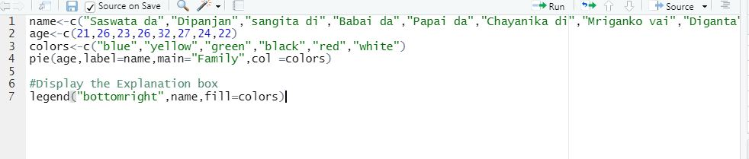

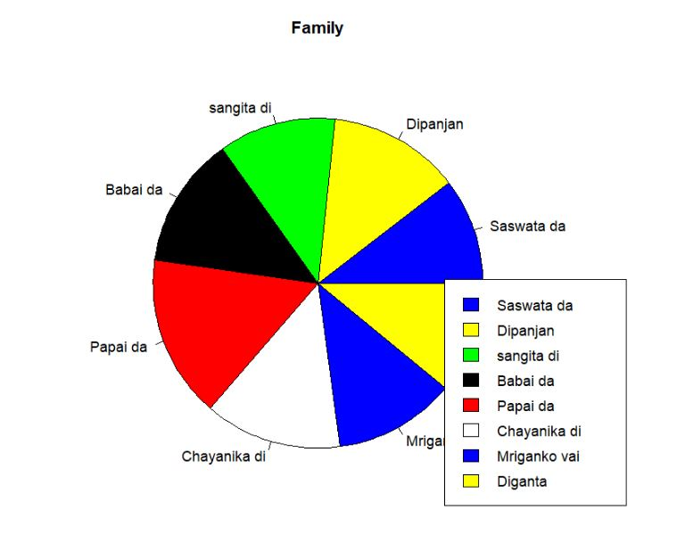

**SCATTERPLOT:-**

**…………………………..**

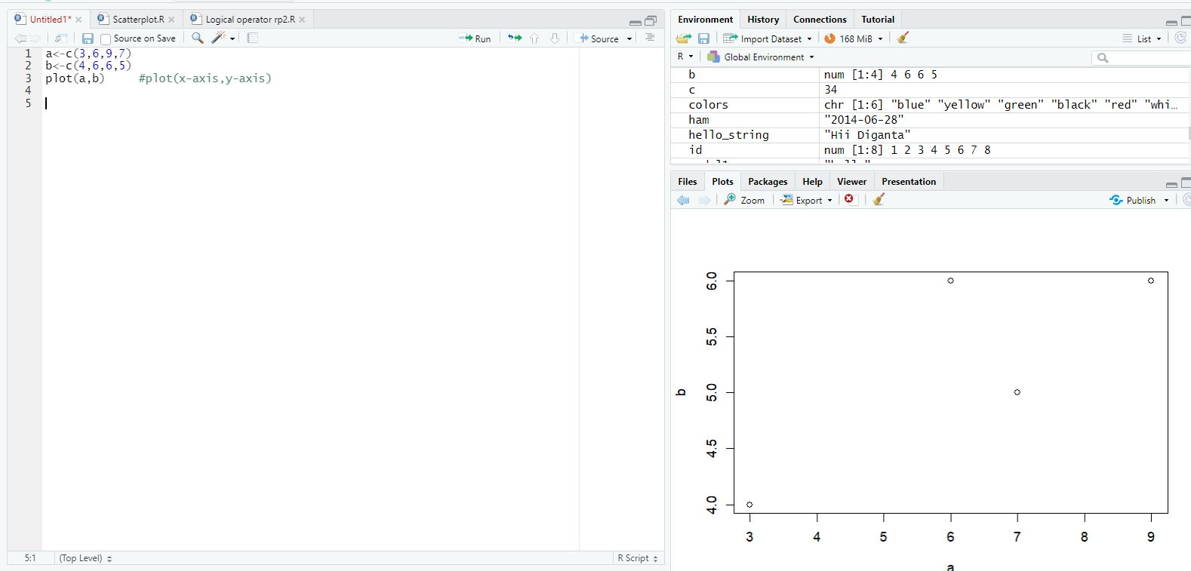

**BARPLOT**

**……………….**

